Apples Information Pack
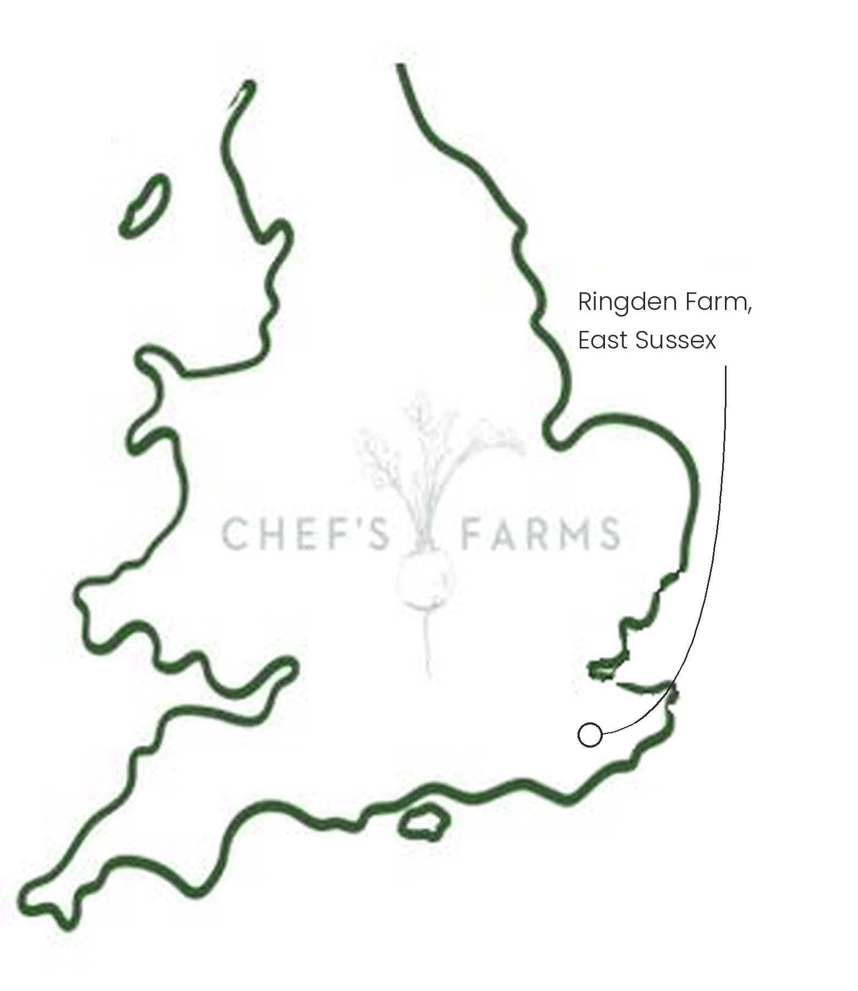
Introduction
Apples are one of the crops the UK grows best. Our cool, damp climate gives the fruit a long, slow ripening period, which builds the crisp texture and sharp, balanced flavour English apples are known for.
Farm Information
Our apples are grown by John Dench at Ringden Farm in the High Weald of East Sussex. John grows more than 25 varieties, from heritage English apples such as Charles Ross, Laxton's Fortune, Lord Lambourne and Worcester to modern favourites like Gala, Braeburn and Jonagold.
Unlike most of the crops we supply, an apple orchard is a long-term investment. The trees stay in the ground cropping for decades, so the soil beneath them is left undisturbed, and the grass alleys between the rows keep it covered all year round, protecting it from erosion and building organic matter over time.
Growing so many varieties spreads the harvest across the season, with early apples like Discovery ready in late summer and later varieties picked into the autumn. Each spring the orchard depends on bees and other pollinators to set the fruit, and a late frost during blossom is the grower's biggest worry. Come harvest, the apples are picked by hand, often over several passes, as fruit on the same tree ripens at different rates.
John also presses Ringden apples into juice and apple cider vinegar, both of which we stock alongside the fruit.
A proper Sussex fruit grower, and we are incredibly proud to support them.
More
Harvest runs from late summer through to October, and the fruit is then kept in cold store, so we can supply English apples well into winter and spring. Bramley and Howgate Wonder are cooking apples that break down into a soft, fluffy purée, while Cox, Russet and Worcester are best eaten raw, sliced into salads or paired with cheese.
Nutritionally, apples are a good source of fibre, particularly pectin, and vitamin C.
Media
See shared album

